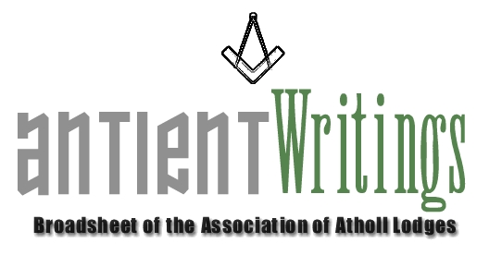

2nd Edition, 2004

New Website Up and Running http://www.antients.com

The ‘new’ web-site is now ready to use!!! Subscribing lodges and individuals are welcome to use it and make it a dynamic facility to assist all with Atholl interests and join in fraternal brotherhood, especially through the Notice Board page, the Histories page and listing your e-mail addresses on the Lodges page. Neil Gardner will now act as Webmaster and he can be contacted via the webCRAFT logo. His services are available to all lodges and Masonic brethren for advice on building web sites, audio & visual work and PR & Media commissions. The temporary site (www.atholl.netfirms.com) will link through for the change over period.

Joining or Renewing Annual Subscriptions

If you and your lodge would like to enjoy the benefits of the Association by subscribing under one of the membership categories please contact Rod Letherby on 020 8690 6749 or email Roderick@rletherby.freeserve.co.uk Subscribing lodges may notate their summons: A Member of the Association of Atholl Lodges

Annual General Meeting

The AGM was held on WEDNESDAY 7th JULY 2004 at Freemasons Hall, Great Queen Street, London. Any subscribing lodge or interested party can obtain a copy of the minutes by contacting the Secretary.

American and Canadian Grand Lodges

The Grand Lodge of New York has accepted ‘Honorary Membership’ to the Association and it is hoped this will encourage fraternal links with the USA. Other links with American and Canadian Grand Lodged are being pursued as is with the Grand Lodge of Ireland.

Regions Required

The N/W of England is a prime area with a cluster of Atholls, so if any lodge in the Manchester or Liverpool areas wish to offer themselves please contact the Secretary who will be pleased to discuss the possibilities with you.

Dermott 2006

2006 sees the 250th anniversary of the publication of Laurence Dermott’s constitution Ahiman Rezon. The Association is planning an ‘event year’ with displays and talks and possibly a publication about the great, but unsung, hero of Antient freemasonry. Keep an eye on the web site for further information and updates. Offers of help are welcomed.

Would Secretaries and Representatives photocopy and distribute as widely as possible

