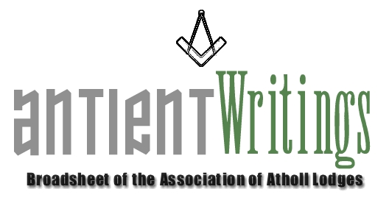

1st Edition, 2005

VW Bro. Walter Crombie PGSwdB

It was with great sadness and following a short illness Walter passed to the Grand Lodge above. He will be missed and remembered for his constant interest and help to the Association as its President. A Memorial Service is to be held at St Paul’s, Covent Garden, London, on 26th April at 12 noon.

Website http://www.antients.com

The web-site is now fully functioning and lodges are encouraged to use it. There is an events and news facility and any items can be included by emailing them to the Webmaster, Neil, via the click-on button on the site.

Joining or Renewing Annual Subscriptions

If you and your lodge would like to enjoy the benefits of the Association by subscribing under one of the membership categories please contact Rod Letherby on 020 8690 6749 or email Roderick@rletherby.freeserve.co.uk Subscribing lodges may notate their summons: A Member of the Association of Atholl Lodges

Notice of Annual General Meeting

The AGM will be held on WEDNESDAY 6th JULY 2005 at Freemasons Hall, Great Queen Street, London, commencing 6pm. Any subscribing lodge wishing to submit a Notice of Motion should write to the Secretary by 4th June 2005.

Regions Required

Any area with a cluster of Atholls who wish to offer themselves as a Region [key hub] for encouraging mutual fraternity between Atholls contact the Secretary who will be pleased to discuss the possibilities with them.

Lodge Information

Lodge of Justice No.147 is relocating to Corvino’s in Middlesex Street, London, from October 2005 [The Gun being earmarked for closure]. Please email lambtikka@aol.com for further information.

Dermott 2006

2006 sees the 250th anniversary of the publication of Laurence Dermott’s constitution Ahiman Rezon. The Association is planning an ‘event year’ with displays and talks and possibly a publication about the great, but unsung, hero of Antient freemasonry. The outline programme is as follows.

Feb/Apr 2006 ……………………..Social Event Sindlesham – Display/Dinner Dance
July 2006…………………………..Formal Opening Display & Luncheon [London Gt Queen St]
SEPT 30TH 2006………………….Event in the North [Stockport - Cheshire]
Dec 2006…………………………..Informal Event to close London Library/Museum Display

Would Secretaries and Representatives photocopy and distribute as widely as possible

Paul Gardner
39 Wentworth Drive, Bedford, BEDS, MK41 8QA
012340261584 secretary @antients.com

